Project: website

UA 2022-2023

# The project

You are requested to design a fully responsive website. See details below.

Please fill in the requested information and upload on Teams.

## Personal info

|  |  |
| --- | --- |
|  | 202011458/Veronica Hoyek/202011458@ua.edu.lb |

## Project Description

|  |  |
| --- | --- |
|  | My website will be an informative one about the K-pop group TWICE, and will contain pages providing members’ introduction, merch, tour dates, YouTube links,to the biggest hits, and the received awards, as well as a contact us page. |

# Website layout

The website should be fully responsive adapted to all screen sizes (mobile, tablet, desktop), as shows the image below.

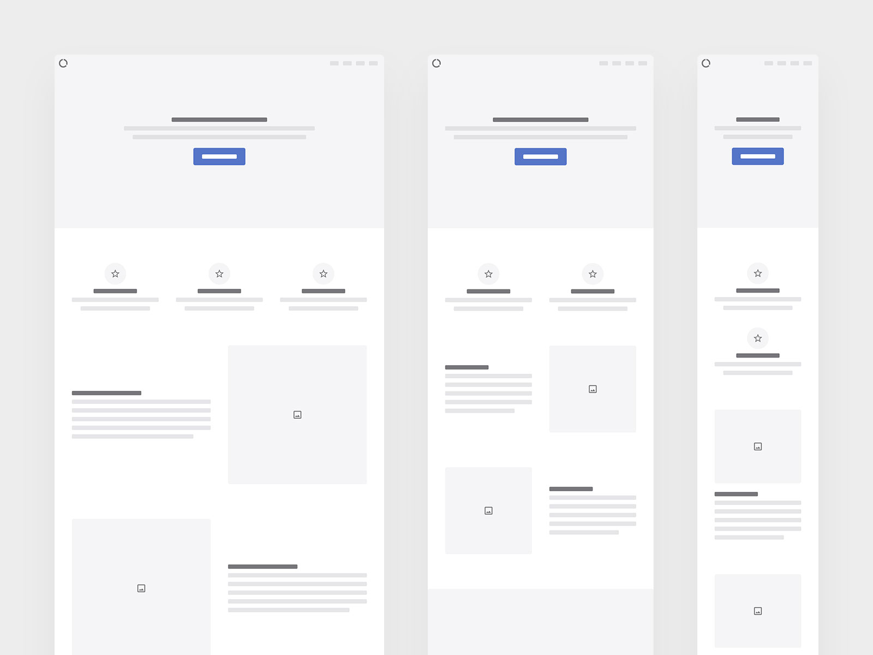

# Site content

1. The project should contain at least 8 pages.
2. All pages should contain a banner in the header of the page that contains a logo that you should create using Adobe Illustrator.
3. All pages should contain a menu/dropdown menu that contains links towards the web pages.
4. All pages should contain a title/logo and header.
5. All pages should contain a footer that contains copyright information with social media links.
6. All pages should take into consideration Search Engine Optimization techniques.
7. A contact page should be created containing a form of submission and validation using HTML5 and CSS.
8. At least one page should contain links to download related files (example: file1.pdf, movie.mp4, etc.)
9. The creativity and innovation of the layout, the user experience, content, comments will be taken into account during the grading process.
10. Include your full name and student ID on every CSS and HTML page as a comment. Explanatory comments should be added where required.

# Folders structure

A correct folder structure should be followed during the development of the website. All names should be in lowercase and written without spaces.

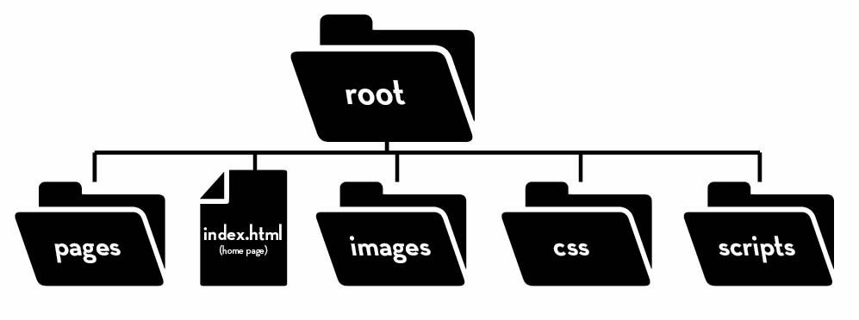

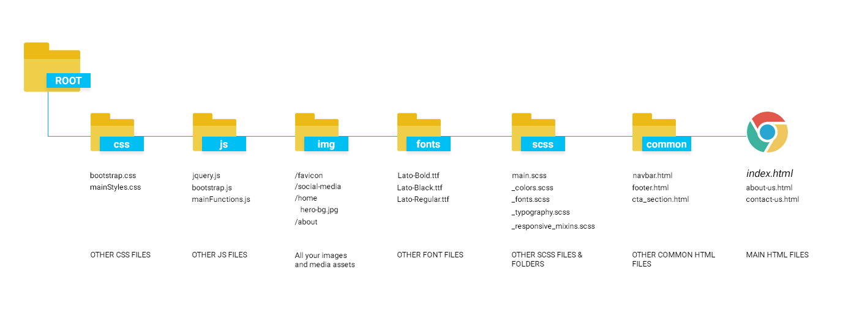

# Project delivery

The project will be zipped and entitled *WD_Firstname_Lastname*,zip and then uploaded on Teams. A presentation for the project will take place in the last 2 sessions.

*Good Luck!*